I2B2-PopMedNet

# User’s Guide

## FDA Pilot

1. Go to: https//fdapiloti2b2.lincolnpeak.com and log on as FDAInvestigator.

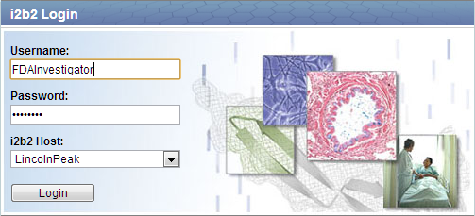

1. Expand SHRINE Ontology in the “Navigate Terms” panel.



1. Drag terms to the “Query Tool” panels. For example, “Female” to Group 1 and “Aortic and peripheral arterial embolism or thrombosis” to Group 2.

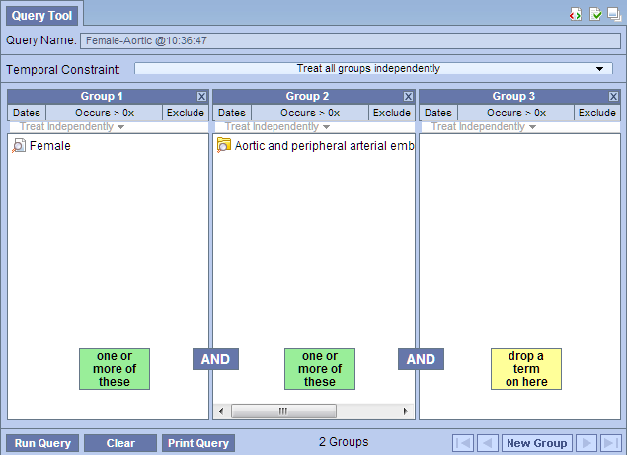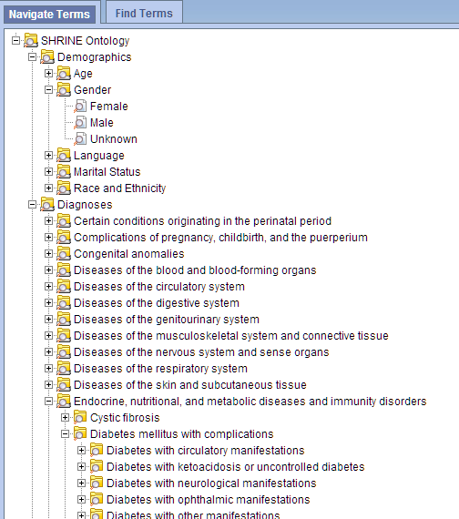

1. Click [Run Query].
2. Name your query and click [OK]. Note: The prototype currently only support “Number of patients” query.

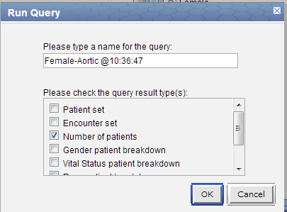

1. Wait for timer to stop in the Query Status panel. The query has now been delivered to PMN for distribution.

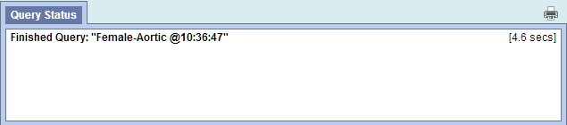

1. Log on the 10.28.119.82 VM and launch DMC.
2. If not yet configured, set up a Network to point to <https://fdapilotquerytool.lincolnpeak.com/api/soap/dmclient>. Two DataMarts are configured to answer I2B2 queries: HPHC – Auto I2B2 DM and Beth Israel. Edit them and point their I2B2 Query Builder models’ Service Url to <https://localhost:9090/pmn>. Set the HPHC –Auto one to automatic. Save configuration.

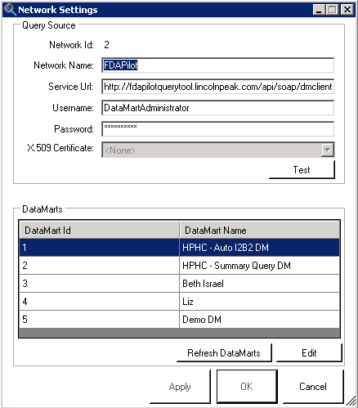

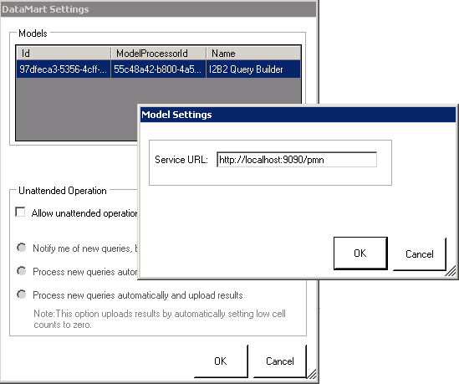

1. The I2B2 queries should now show up on the main screen. Select each and you should see the queries in HQMF format. Run the queries.

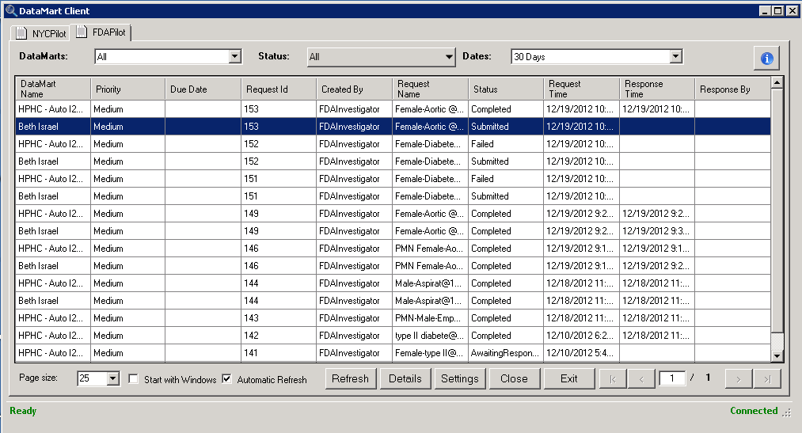

1. When the results return, click [Upload]. The results should now be uploaded to PMN.
2. Back on the I2B2 Web Client, login again if the session has expired.
3. In the Previous Query panel, right click and select “Refresh All”. You should now see your most recent query at the top of the list. Drag this to Query Tool panel’s Query Name textbox. I2B2 Web Client will now start pulling data from PMN.

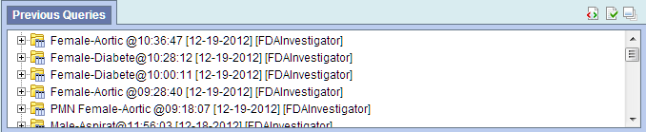

1. In a moment, you shall see both results in the Query Status panel.

